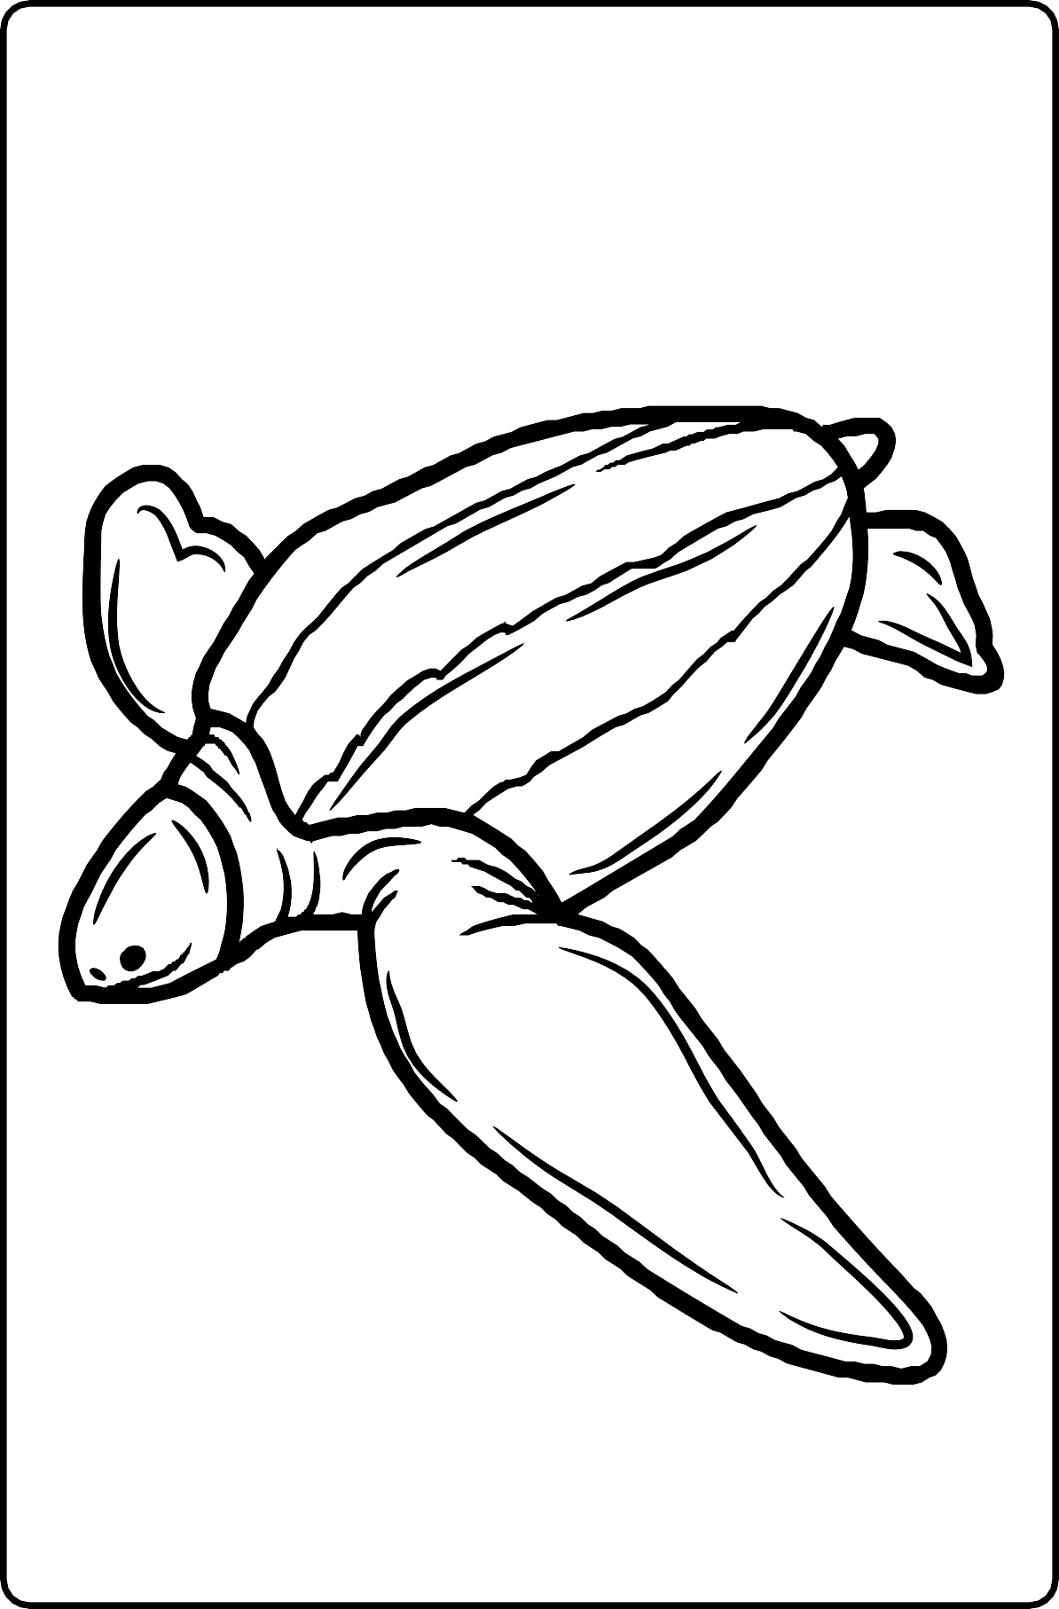

Name: _________________________

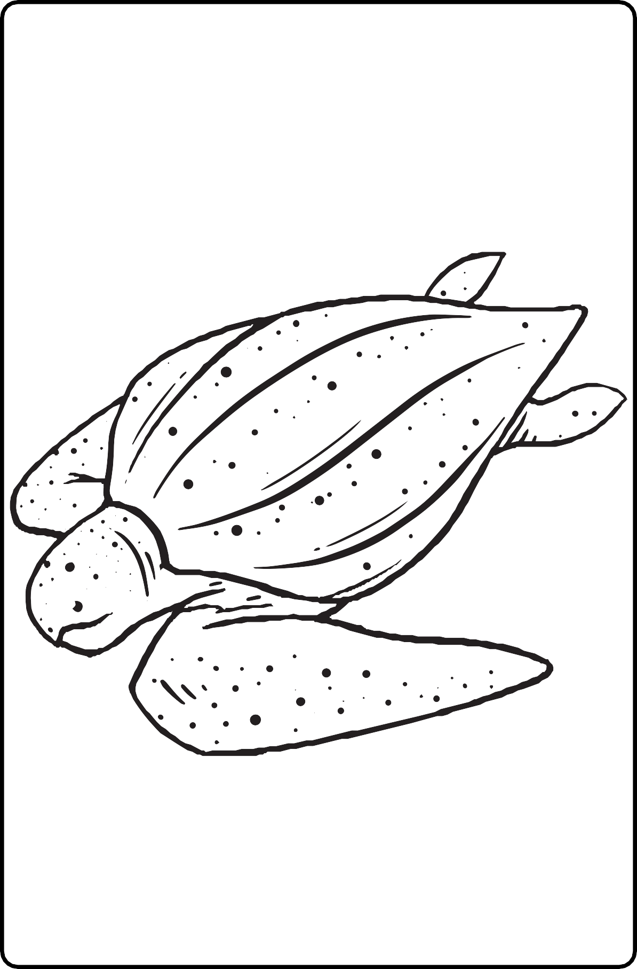

Name: _________________________